

Whitchurch Primary School Writing texts and Outcomes 2023-2024

Year 6
Term 1 |  | Term 2 |  | Term 3 | Term 4 |  | Term 5 |  | Term 6
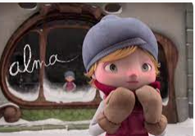  Alma  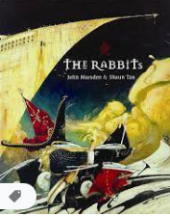  The Rabbits –  John Marsden |  | Continue with Hugo Cab  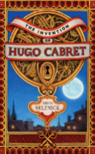  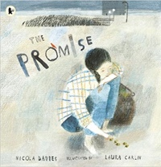  The Promise – Nicola Davies |  | 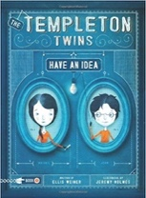  Windrush Child – Benjamin Zephaniah  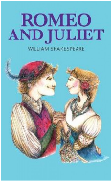  Romeo and Juliet – William Shakespeare | 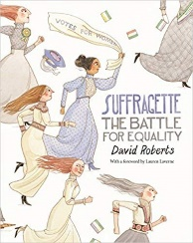  Suffragette: The Battle for Equality – David Roberts |  | 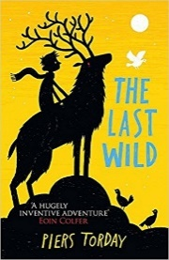  The Last Wild – Piers Torday |  | 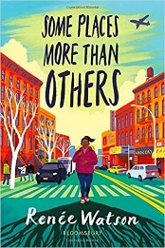  Some Places More Than Others – Renee Watson
Predictions  Instructions  Story Sequel  Formal Speech  Brochure  Diary Entry  Balanced Argument |  | Narrative  Setting Description  Diary Entry  Letter  Newspaper Report  Experimentation with figurative language  Sequel – narrative |  | Informal Letter  Advice  Formal Persuasive Letter  Narrative  Setting Description  Diary Entry  Letter  Newspaper Report | Speeches  News Reports  Balanced arguments  Letters  Persuasive Campaign |  | Character Description  Setting Description  Formal Letters  Formal Reports  Own version dystopia narrative |  | Letters  Diary entry  Information leaflets  Instructions  Poetry
Year 4/5
Term 1 | Term 2 |  | Term 3 |  |  | Term 4 |  | Term 5 | Term 6
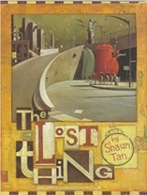  The Lost Thing – Shaun Tan  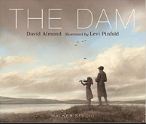  The Dam – David Almond | 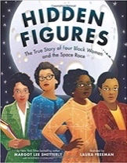  Hidden Figures – Margot Lee Shetterley |  | 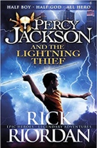  Percy Jackson and the Lightening Thief – Rick Riordan  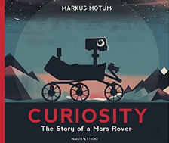  Curiosity – Markus Motum |  |  | 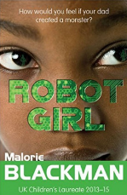  Robot Girl – Malorie Blackman  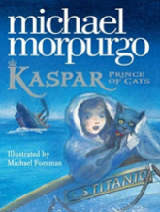  Kaspar, Prince of Cats – Michael Morpurgo |  | 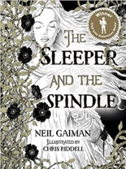  The Sleeper and the Spindle- Neil Gaiman and Chris Riddell  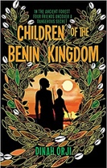  Children of the Benin Kingdom – Dina Orji | 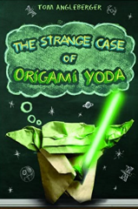  The Strange Case of Oregami Yoda – Tom Angleberger
Formal letters  Character and setting descriptions  Non-chronological reports  Narratives- fantasy  Sections of dialogue  Setting and character descriptions  Diary Entry  Narrative Retelling | Non-chronological report  Formal persuasive letter  Informal letter  Diary entry  Character descriptions  News report  Memoir |  | Figurative language  Setting description  Mythical narrative  Short explanation  News report  Proposal to NASA  Expanded explanation |  |  | Discussion  Debate  Character Comparisons  Science-fiction narrative  Character description  Balanced report  Advertising Leaflet  Newspaper articles |  | Setting descriptions  Character descriptions  Diaries, dialogue  Fairy tale narrative  Instructions  Persuasion  Diaries  Non-chronological report | Instructions  Persuasion  Recount  Discussion text

Year 4
Term 1 | Term 2 | Term 3 | Term 4 | Term 5 | Term 6
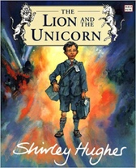  The Lion and the Unicorn – Shirley Hughes  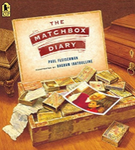  The Matchbox Diary – Paul Fleischman | 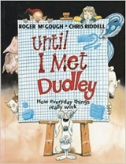  Until I Met Dudley – Roger McGough and Chris Riddell  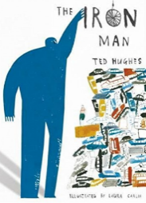  Iron Man – Ted Hughes | 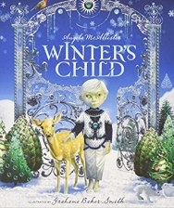  Winter’s Child – Angela McAllister  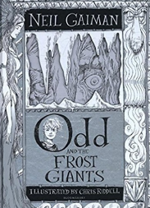  Odd and the Frost Giants – Neil Gaiman | 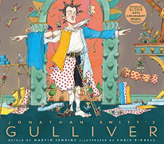  Jonathon Swift’s Gulliver –Martin Jenkins  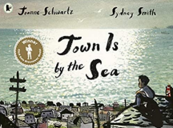  Town is by the Sea – Joanne Schwartz | 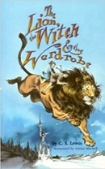  The Lion, The Witch and The Wardrobe – CS Lewis | 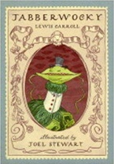  Jabberwocky – Lewis Carroll and Joel Stewart
Letters  Diary entry  Character and setting description  Non-chronological report  Biography  Ship log  Dialogue  Non-chronological report | Explanation  Short explanatory paragraphs  Two explanation texts - formal and informal  Character description  Letter of advice  Menu using descriptive devices  Mystery Narrative | Recount (letter)  Setting description  Fantasy Story Sequel  Narrative recounts  Character and setting descriptions  Narrative retelling from alternative perspective | Formal letter  Interview diary  Newspaper report  Book jacket with blurb  Comparisons  Narratives sequel | Eye witness reports  Conversations  Write in role  Own version narrative (set in another world) | Explanatory description  Performance poetry  Nonsense poetry

Year 3
Term 1 | Term 2 | Term 3 | Term 4 | Term 5 | Term 6
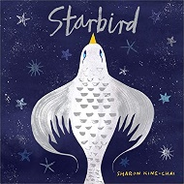  Starbird – Sharon King-Chai  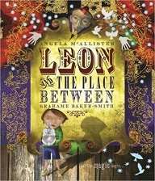  Leon and the Place Between – Angela McAllister | 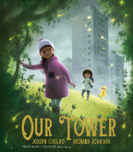  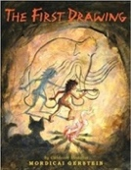  The First Drawings – Mordecai Gerstein  Our Tower – Joseph Coelho | 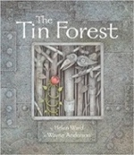  The Tin Forest by Helen Ward and Wayne Anderson  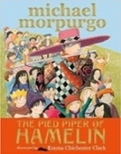  The Pied Piper of Hamelin – Michael Morpurgo and Emma Chichester-Clark | 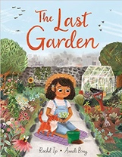  The Last Garden – Rachel Ip  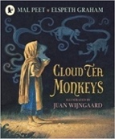  Cloud Tea Monkeys – Mal Peet | 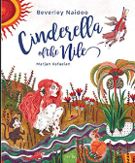  Cinderella of the Nile – Beverley Naidoo  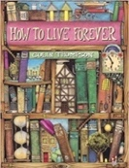  How to live forever – Colin Thompson | 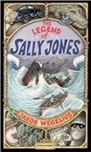  The Legend of Sally Jones – Jakob Wegelius  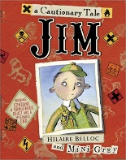  Jim – Hilarie Belloc and Mini Grey
Advice  Postard  Writing in role  Fable  Setting description  Persuasive poster  Dialogue  Own version fantasy narrative | Character description  Recount  Own Historical Narrative  Setting description  Dialogue  Poem  Retell narrative | Persuasive poster  Information leaflet  Persuasive information text  Writing in role  Character and setting description  Own myth/legend narrative | Setting descriptions  Dialogue  Social media updates  Own narrative  Instructions  How-to guides  Non-chronological report | Descriptive passages  Letters  Own version narrative  Persuasive letter  Character and setting description  Instructions | Letters  Books of tricks  Emails  Narrative – further adventure  Performance poetry  Warning poster  Alternative endings

Year 2
Term 1 | Term 2 | Term 3 | Term 4 | Term 5 | Term 6
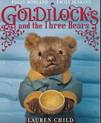  The Goldilocks Project  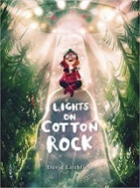  Lights on Cotton Rock – David Litchfield | 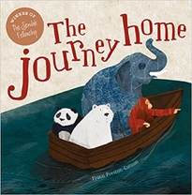  The Journey Home – Frann Preston-Gannon  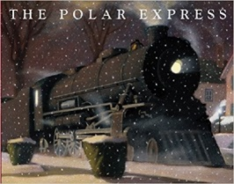  The Polar Express - Chris Van Allsburg | 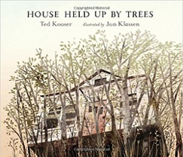  House Held up by Trees – Ted Kooser  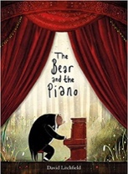  The Bear and the Piano – David Litchfield | 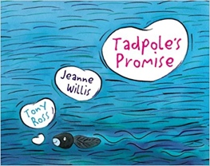  Tadpole’s Promise – Jeanne Willis and Tony Ross  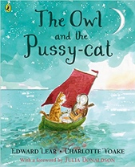  The Owl and the Pussy Cat - Edward Lear | 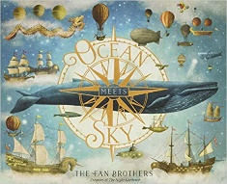  Ocean Meets Sky – Eric Fan and Fan Terry  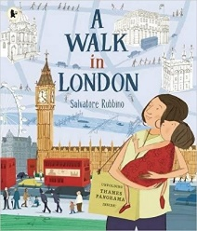  A Walk in London – Salvatore Rubbino | 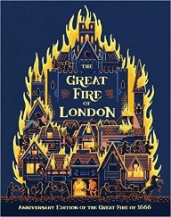  The Great Fire of London – Emma Adams and James Weston Lewis  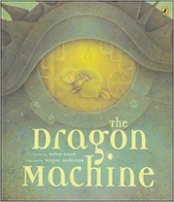  The Dragon Machine – Wayne Anderson and Helen Ward
Setting description  Letter  Narrative  Character description  Writing in role  Innovative narrative | Fact file  Postcard  Innovative story  Letter  First person narrative | Descriptive non-fiction reports  Instructions  Letter of advice  Writing in role  Innovative narrative | Setting descriptions  Speech bubbles  Innovative narrative  Letter  Instructions  Poetry | Setting description  Character descriptions  Dialogue  Fantasy Narrative  Recount of trip in the local area  Guide book | Guide to London buildings  Diary entry in role  Dragon guide  Descriptions  Innovative narrative

Year 1
Term 1 | Term 2 | Term 3 | Term 4 | Term 5 | Term 6
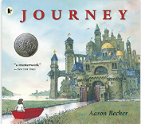  The Journey – Aaron Becker  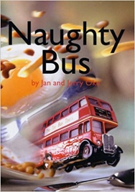  Naughty Bus – Jan Oke | 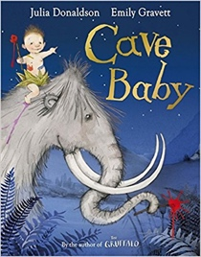  Cave Baby – Julia Donaldson and Emily Gravett  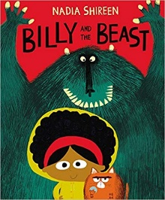  Billy and the Beast – Nadia Shireen | 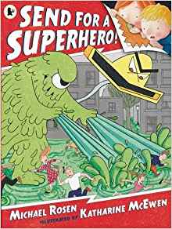  Send for a Superhero – Michael Rosen and Katherine McEwan  The Odd Egg – Emily Gravett  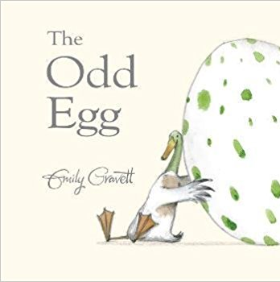 | 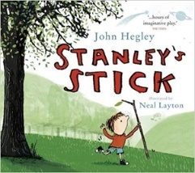  Stanley’s Stick – John Hegley and Neal Layton  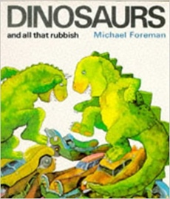  Dinosaurs and all that rubbish – Michael Foreman | 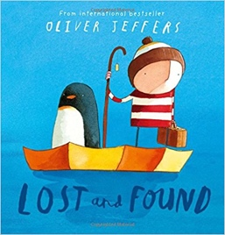  Lost and Found – Oliver Jeffers  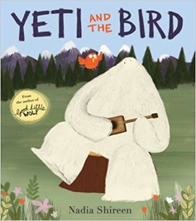  Yeti and the Bird – Nadia Shireen | 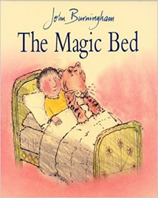  The Magic Bed – Jon Burningham  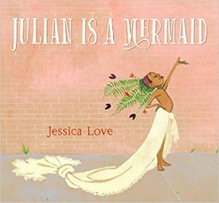  Julian is a Mermaid – Jessica Love
Predictions  Posters  Travel diary  Retellings in role  Captions  Recount of trip  Narrative – retell of story | Labels  Captions  Narrative – retell of story  Wanted poster  Character description  Instructions (recipe)  Innovative ‘defeat a monster’ story | Speech bubbles  Wanted poster  Character description Innovative super hero narrative  Speech bubbles  Diary entry  Letter  Non-fiction report | Retellings  Setting descriptions  Own version narrative  Information booklet  Letters  Instructions | Character descriptions  Retellings  Instructions  Postcard  Letters  Own version narrative | Setting descriptions  Description of magical furniture  Fantasy story  Writing in role  Advertisement  Poem

Reception
Term 1 | Term 2 | Term 3 | Term 4 | Term 5 | Term 6
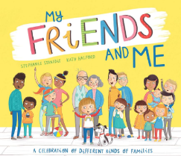  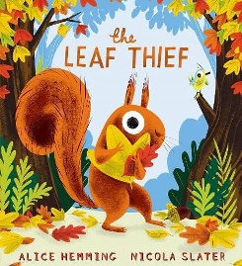  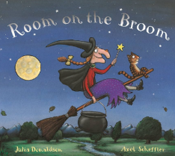  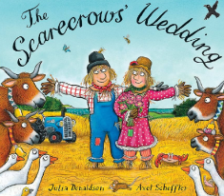  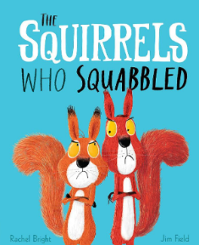 | 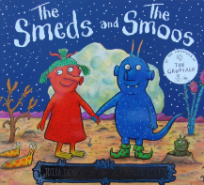  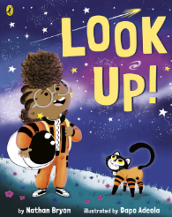  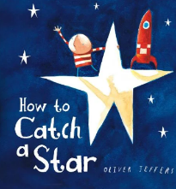  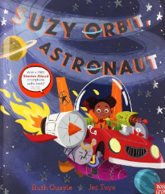  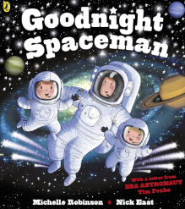  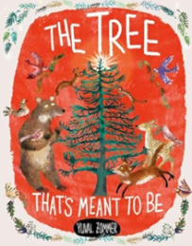  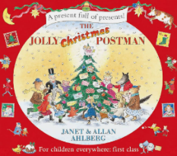 | 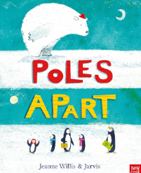  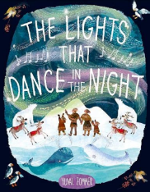  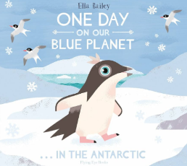  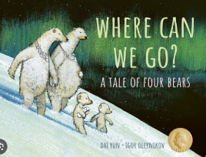  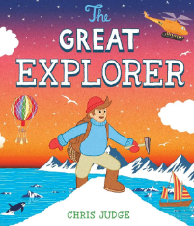  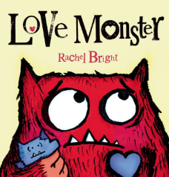  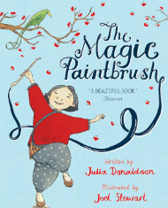 | 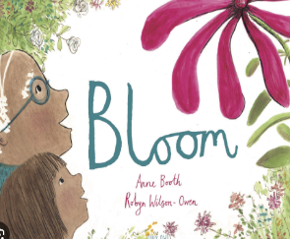  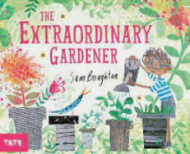  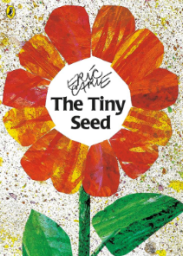  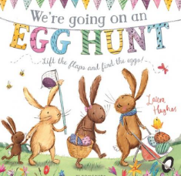  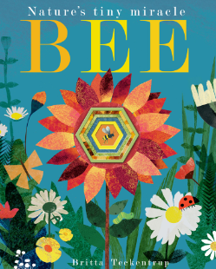  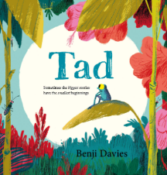 | 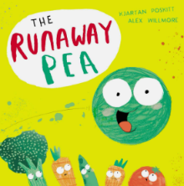  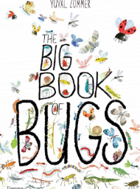  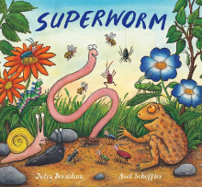  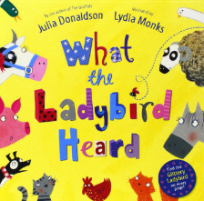  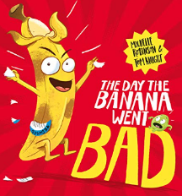  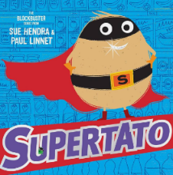 | 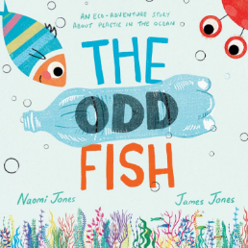  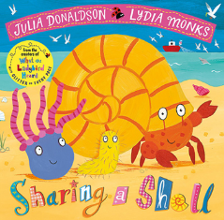  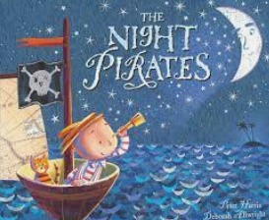  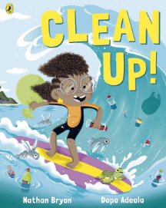  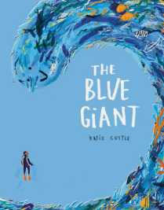  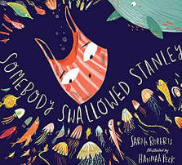  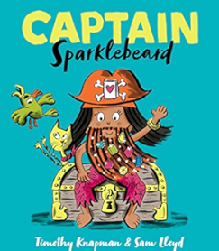
- Oral retelling  - Identifying initial sounds in words  - Labels | - Labels  - Lists  - Letter | - Writing in role  - Lists  - Setting description  - Letter | - Instructions (First, Then, Next, Finally…)  - Statements  - lists  - Character description  - Retell a narrative | - Questions  - Instructions (First, Then, Next, Finally…)  - Rewrite narrative | - Speech  - ‘How to be a pirate’ guide  - Setting description  - Character description  - Rhyming

