
Mathematics Calculation Policy
ADDITION
Reception  Statutory Guidance  Verbally count beyond 20, recognising the pattern of the counting system.  Compare quantities up to 10 in different contexts, recognising when one quantity is greater than, less than or the same as the other quantity.  e.g. 6 add 4    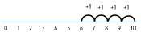 | Year 1  Statutory Guidance  Add one-digit and two-digit numbers to 20, including 0.  Solve one-step problems that involve addition, using concrete objects and pictorial representations, and missing number problems.  e.g. 8 + 6 =  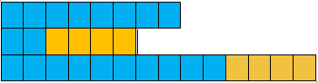  Concrete objects:  Add by making 10  Pictorial representation:  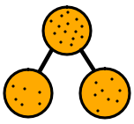  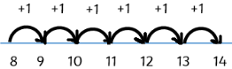  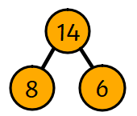  Abstract: | Year 2  Statutory Guidance  Solve problems with addition:  - using concrete objects and pictorial representations, including those involving numbers, quantities and measures  - applying their increasing knowledge of mental and written methods  Add numbers using concrete objects, pictorial representations, and mentally, including:  - a two-digit number and 1s  - a two-digit number and 10s  - 2 two-digit numbers  - adding 3 one-digit numbers  e.g. 13 + 21 =  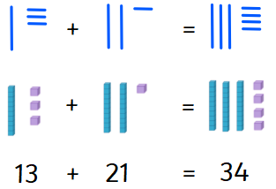  Using Base 10 model or Dienes to add two-digit numbers. | Year 3  Statutory Guidance  Add numbers with up to 3 digits, using formal written methods of columnar addition.  Solve problems, including missing number problems, using number facts, place value, and more complex addition.  e.g. 265 + 164 =  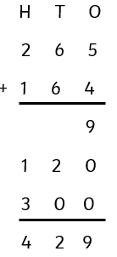  Expanded column method:  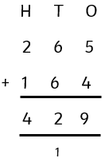  Compact column method: | Year 4  Statutory Guidance  Add numbers with up to 4 digits using the formal written methods of columnar addition.  Solve addition two-step problems in contexts, deciding which operations and methods to use and why.  e.g. 5532 + 248 =  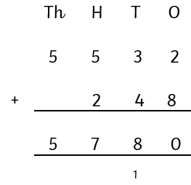 | Year 5  Statutory Guidance  Add whole numbers with more than 4 digits, including using formal written methods (columnar addition).  Solve addition multi-step problems in contexts, deciding which operations and methods to use and why.  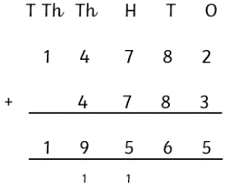  e.g. 14782 + 4783 = | Year 6  Statutory Guidance  Solve addition multi-step problems in contexts, deciding which operations and methods to use and why.
Vocabulary  add, more, make, and, total, is the same as, altogether, how many more to make…? | Vocabulary  add, more, plus, make, sum, total, altogether, equals, is the same as, partition, represent, how many more to make…? | Vocabulary  add, addition, more, plus, make, sum, total, altogether, equals, is the same as, partition, represent, how many more to make…? one more…, two more…, ten more… | Vocabulary  add, addition, more, plus, increase, make, sum, total, altogether, equals, is the same as, estimate, how many more to make…? one more…, two more…, ten more…, one hundred more… | Vocabulary  add, addition, more, plus, increase, make, sum, total, altogether, equals, is the same as, estimate, how many more to make…? Ones, tens, hundreds, thousands, tenths, hundredths, decimal point | Vocabulary  add, addition, more, plus, increase, make, sum, total, altogether, equals, is the same as, estimate, how many more to make…? ones, tens, hundreds, thousands, tenths, hundredths decimal point | Vocabulary  add, addition, more, plus, increase, make, sum, total, altogether, equals, is the same as, estimate, how many more to make…? ones, tens, hundreds, thousands, millions, tenths, hundredths, thousandths, decimal point

Mathematics Calculation Policy
SUBTRACTION
Reception  Statutory Guidance  Verbally count beyond 20, recognising the pattern of the counting system  Compare quantities up to 10 in different contexts, recognising when one quantity is greater than, less than or the same as the other quantity.  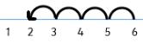  e.g. 6 subtract 4  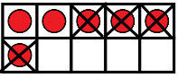 | Year 1  Statutory Guidance  Subtract one-digit and two-digit numbers to 20, including 0.  Solve one-step problems that involve subtraction, using concrete objects and pictorial representations, and missing number problems.  e.g. 8 - 6 =  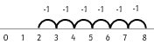  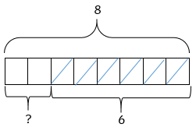  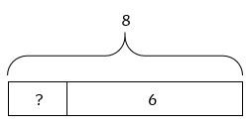 | Year 2  Statutory Guidance  Solve problems with subtraction:  - using concrete objects and pictorial representations, including those involving numbers, quantities and measures  - applying their increasing knowledge of mental and written methods  Subtract numbers using concrete objects, pictorial representations, and mentally, including:  - a two-digit number and 1s  - a two-digit number and 10s  - 2 two-digit numbers  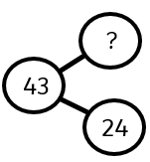  e.g. 43 - 24 =  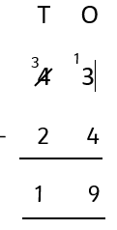  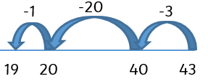 | Year 3  Statutory Guidance  Subtract numbers with up to 3 digits, using formal written methods of columnar subtraction.  Solve problems, including missing number problems, using number facts, place value, and more complex subtraction.  e.g. 275 - 167 =  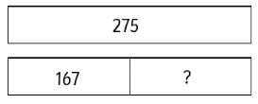  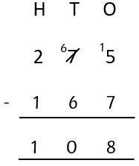 | Year 4  Statutory Guidance  Subtract numbers with up to 4 digits using the formal written methods of columnar subtraction.  Solve subtraction two-step problems in contexts, deciding which operations and methods to use and why.  e.g. 5532 - 1248 =  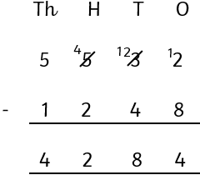 | Year 5  Statutory Guidance  Subtract whole numbers with more than 4 digits, including using formal written methods (columnar subtraction).  Solve subtraction multi-step problems in contexts, deciding which operations and methods to use and why.  e.g. 24784 - 4289 =  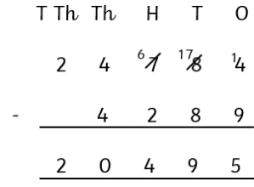 | Year 6  Statutory Guidance  Solve subtraction multi-step problems in contexts, deciding which operations and methods to use and why.
Vocabulary  subtract, less, left over, leave, how many are left? how many are gone? | Vocabulary  subtract, less, left over, how many are left? how many are gone? | Vocabulary  subtract, subtraction, less, left over, decrease, difference, exchange, ones, tens | Vocabulary  subtract, subtraction, less, left over, decrease, difference, exchange, ones, tens, hundreds, inverse | Vocabulary  subtract, subtraction, less, left over, decrease, difference, exchange, ones, tens, hundreds, thousands, inverse | Vocabulary  subtract, subtraction, less, left over, decrease, difference, exchange, ones, tens, hundreds, thousands, tenths, hundredths, decimal point. inverse | Vocabulary  subtract, subtraction, less, left over, decrease, difference, exchange, ones, tens, hundreds, thousands, millions, tenths, hundredths, thousandths, inverse

Mathematics Calculation Policy
MULTIPLICATION
Reception  Statutory Guidance  Explore and represent patterns within numbers up to 10, including evens and odds, double facts and how quantities can be distributed equally.  e.g. double the spots on the ladybird   | Year 1  Statutory Guidance  Solve one-step problems involving multiplication by calculating the answer using concrete objects, pictorial representations and arrays with the support of the teacher.  e.g. 3 groups of 4  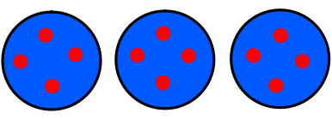  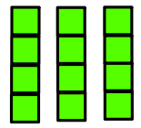 | Year 2  Statutory Guidance  Recall and use multiplication facts for the 2, 5 and 10 multiplication tables.  Calculate mathematical statements for multiplication within the multiplication tables and write them using the multiplication (×) and equals (=) signs.  Solve problems involving multiplication using materials, arrays, repeated addition, mental methods, and multiplication facts, including problems in contexts.  e.g. 5 x 4 =  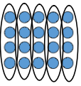  4+4+4+4+4 = 20  5 x 4 = 20  4 x 5 = 20 | Year 3  Statutory Guidance  Recall and use multiplication facts for the 3, 4 and 8 multiplication tables.  Write and calculate mathematical statements for multiplication using the multiplication tables that they know, including for two-digit numbers times one-digit numbers, using mental and progressing to formal written methods.  e.g. 34 x 5 =  Long multiplication method:  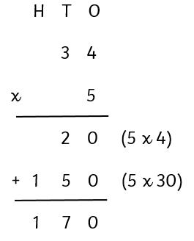  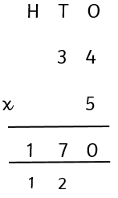  Short multiplication method: | Year 4  Statutory Guidance  Recall multiplication facts for multiplication tables up to 12 × 12.  Multiply two-digit and three-digit numbers by a one-digit number using formal written layout.  e.g. 254 x 4 =  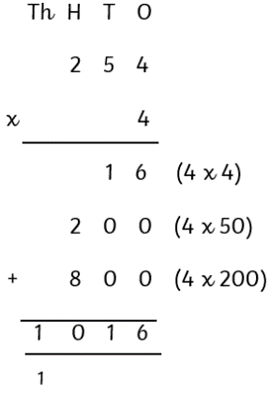  Long multiplication method:  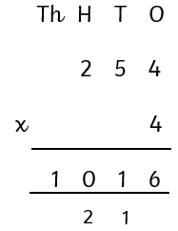  Short multiplication method: | Year 5  Statutory Guidance  Multiply numbers up to 4 digits by a one- or two-digit number using a formal written method, including long multiplication for two-digit numbers.  Multiply whole numbers and those involving decimals by 10, 100 and 1000.  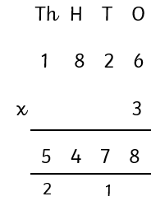  e.g. 1826 x 3 = | Year 6  Statutory Guidance  Multiply multi-digit numbers up to 4 digits by a two-digit whole number using the formal written method of long multiplication.  e.g. 2735 x 28 =  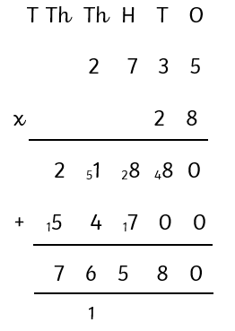
Vocabulary  double, even, odd, groups of, number patterns | Vocabulary  double, groups of, lots of, multiply, repeated addition, array, row, column, equal groups | Vocabulary  multiply, multiplication, multiplied by, groups of, times, repeated additions, array, row, column, equal groups, doubling, times tables | Vocabulary  multiply, multiplication, multiplied by, multiplied into groups of, times, multiple, factor, product repeated additions, array, row, column, equal groups, doubling, times tables | Vocabulary  multiply, multiplication, multiplied by, multiplied into groups of, times, multiple, factor, product repeated additions, array, row, column, equal groups, doubling, times tables, squared, cubed | Vocabulary  multiply, multiplication, multiplied by, multiplied into groups of, times, multiple, factor, product repeated additions, array, row, column, equal groups, doubling, times tables, squared, cubed | Vocabulary  multiply, multiplication, multiplied by, multiplied into groups of, times, multiple, factor, product repeated additions, array, row, column, equal groups, doubling, times tables, squared, cubed

Mathematics Calculation Policy
DIVISION
Reception  Statutory Guidance  Explore and represent patterns within numbers up to 10, including evens and odds, double facts and how quantities can be distributed equally.  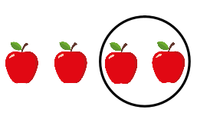  e.g. halve the amount of apples | Year 1  Statutory Guidance  Solve one-step problems involving division by calculating the answer using concrete objects, pictorial representations and arrays with the support of the teacher.  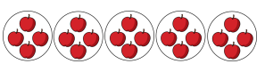  e.g. share 20 apples equally into 5 groups | Year 2  Statutory Guidance  Recall and use division facts for the 2, 5 and 10 multiplication tables.  Calculate mathematical statements for division and write them using the division (÷) and equals (=) signs.  Solve problems involving division, using materials, arrays, mental methods, and division facts, including problems in contexts.  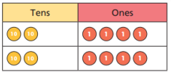  e.g. 48 ÷ 2 =  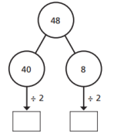  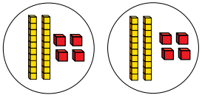 | Year 3  Statutory Guidance  Recall and use division facts for the 3, 4 and 8 multiplication tables.  Write and calculate mathematical statements for division using the multiplication tables that they know.  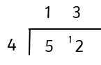  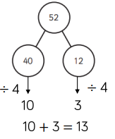  e.g. 52 ÷ 4 =  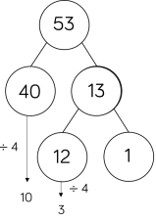  53 ÷ 4 = 13 r 1 | Year 4  Statutory Guidance  Recall division facts for multiplication tables up to 12 × 12.  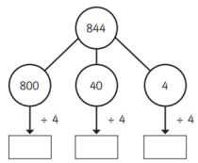  e.g. 844 ÷ 4 =  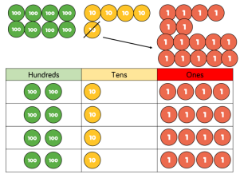  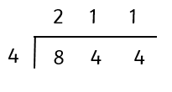 | Year 5  Statutory Guidance  Divide numbers up to 4 digits by a one-digit number using the formal written method of short division and interpret remainders appropriately for the context.  Divide whole numbers and those involving decimals by 10, 100 and 1000.  e.g. 8533 ÷ 2 =  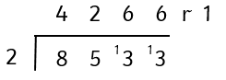 | Year 6  Statutory Guidance  Divide numbers up to 4 digits by a two-digit whole number using the formal written method of long division, and interpret remainders as whole number remainders, fractions, or by rounding, as appropriate for the context.  Divide numbers up to 4 digits by a two-digit number using the formal written method of short division where appropriate, interpreting remainders according to the context.  e.g. 432 ÷ 12 =  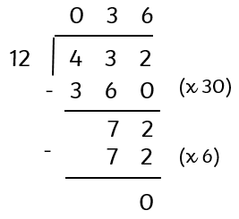  Long division method:  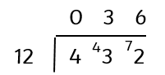  Short division method:
Vocabulary  half, even, odd, groups of, share, equal, number patterns | Vocabulary  half, groups of, lots of, divide, share, equal groups | Vocabulary  divide, division, divided by, equal groups of, share equally, halving, left over | Vocabulary  divide, division, divided by, divided into, equal groups of, share equally, halving, sharing, left over, remainder | Vocabulary  divide, division, divided by, divided into, equal groups of, share equally, halving, sharing, left over, remainder, dividend, divisor, quotient | Vocabulary  divide, division, divided by, divided into, equal groups of, share equally, halving, sharing, left over, remainder, dividend, divisor, quotient | Vocabulary  divide, division, divided by, divided into, equal groups of, share equally, halving, sharing, left over, remainder, dividend, divisor, quotient

