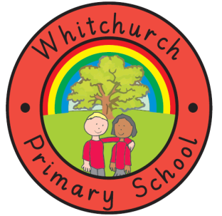

Reading vision
A child’s reading skills are important to their success in school as they will allow them to access the breadth of the curriculum and improve their communication and language skills.
Additionally, reading can be an enjoyable and imaginative time for children, which can open doors to all kinds of new worlds for them. Through reading, children have the opportunity to develop culturally, socially and emotionally as well as reaping the benefits academically. At Whitchurch Primary School a ‘Love of Language’ is developed and fostered for the enjoyment, challenge and understanding of text. This love of language is developed through poetry, a variety of fictional genres and non-fiction, test questions and even through research.
At Whitchurch Primary School we have a structured approach to the teaching of reading. We use a wide range of reading materials including iPads, newspapers and books to help children learn to read in a way which meets their needs and challenges them appropriately. Throughout school, we have a rich collection of published books in order to encourage children’s desire to become readers.
Across the Early Years Foundation Stage and Key Stage One, we teach phonics in order to develop a wide vocabulary for all children. In Key Stage Two children continue to use these phonics skills and are supported to keep their knowledge current. Our aim is to teach children to not only read fluently, but to improve their comprehension skills as this will help children to understand and reflect upon what they have read. The types of questions children will explore are linked to the key comprehension skills; vocabulary, infer, predict, explain, retrieve and sequence/summarise.
We acknowledge and value the important role played by the family in supporting children’s reading development by reading to them and listening to them read. Books are taken home on a daily basis along with a reading record so that children can be heard reading a comment can be made. Children should read and a comment should be written in their reading records at least 3 times a week.
Reading for pleasure is at the very core of our curriculum here at Whitchurch Primary School and we use books through every aspect of our learning. This way of learning helps make links between curriculum areas, provides context for the children and highlights the importance of reading whilst also encouraging an enjoyment for it too.

