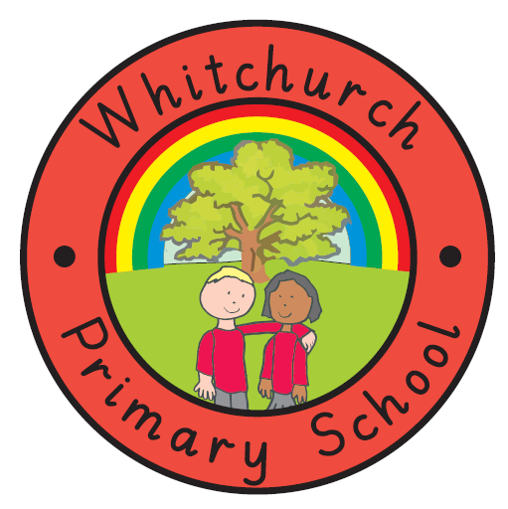
WHITCHURCH PRIMARY SCHOOL

Achieving Our Best Together

WHOLE SCHOOL FOOD POLICY

Introduction
At Whitchurch Primary School we believe that knowledge and understanding of nutrition is essential for good health and effective teaching and learning. We recognise the important connection between a healthy diet and a child's ability to learn effectively and achieve high standards in school.

Aims and Objectives
- To improve the health of staff, pupils and their families by helping to influence their eating habits through increasing their knowledge and awareness of food issues, including what constitutes a healthy, balanced diet.

- To develop healthy eating and drinking habits that will last beyond pupils’ time at our school.

- To give pupils the information they need to make healthy choices.

- To ensure that we are giving consistent messages about food and health.

- To ensure that food provision in the school reflects the ethical and medical requirements of all children and staff e.g. religious, ethnic, vegetarian, medical and allergenic needs.

- To encourage fluid intake, with an easily accessible water supply provided throughout the day.

- To make the provision and consumption of food an enjoyable and pleasant experience that enhances the social development of all children.

- To contribute to the healthy physical development of all members of our school community.

9. To enable our children to experience the planting, growing, harvesting,
preparing and cooking of healthy fresh food.

Break Time Snacks
All pupils in EYFS and Key Stage One take part in the National Fruit and Vegetable Scheme and receive a free piece of fruit or vegetable at morning break.
To help establish healthy choices from an early age, fruit and vegetables are the only snacks permitted for all key stages.
SCHOOL LUNCHES
All our school meals are cooked onsite by a team employed by the school. The menu for the week is displayed in each classroom and in the dining hall and a copy is also emailed to parents. This can also be viewed on our website.
Fruit and vegetables grown in the school growing beds that are not used in the children’s kitchen will be given to the school cook to be used in the children’s hot school meals.
Alternatively, children may bring a packed lunch to school.

THE DINING ENVIRONMENT
Most children eat their midday meal in the school hall. The children are allowed to choose where they sit, which encourages a social setting where they can eat with their friends.
Staff are encouraged to eat school lunches in the dining hall.
We ask the children to respect the dining experience of others by keeping an appropriately noise level. We also want the dining environment to be an attractive and inviting place to eat, where children are encouraged to interact with each other and enjoy their food. A map of the world and posters in the hall promote healthy eating.

DRINKS
We recognise that low fluid intake can lead to reduced academic performance through poor concentration and lethargy, reduced physical performance and health problems. We encourage all children to drink water at regular intervals throughout the school day. Water is freely available to all members of the school community. Every child is encouraged to bring a bottle of water to school to keep in the classroom. Only water may be drunk during the school day, except at lunchtime when children who bring a packed lunch from home may drink juice, squash or milk drinks.
In the Foundation Stage all pupils sit down for a drink when at mid-morning break. Up until the term following their fifth birthday, children in the Foundation Stage are provided with a free carton of milk to drink at this point and other pupils drink from their water bottles.

FOOD ACROSS THE CURRICULUM
There are a number of opportunities for children to develop their knowledge and understanding of food and healthy eating within the curriculum. It is covered in the formal curriculum through PSHE and Citizenship, Food Technology (within Design Technology), Religious Education and Science.

PSHE and Citizenship encourages the children to take responsibility for their own health and teaches them how to develop a healthy lifestyle.
Religious and cultural influences on food and eating habits are also explored, as they are in aspects of the RE curriculum.

Food Technology provides the opportunity to learn about where food comes from and apply healthy eating messages through practical work with food, including food preparation and cooking. We plan opportunities for the children to work in the environmental area and grow fruits and vegetables.

Science provides an opportunity to learn about the types of food available, their nutritional composition, digestion and the function of different nutrients in contributing to health.

Aspects of food and healthy eating are also covered in other curriculum areas and through themed weeks and the celebration of various festivals.

MONITORING AND REVIEW
This policy will be reviewed annually to take account of new developments.

