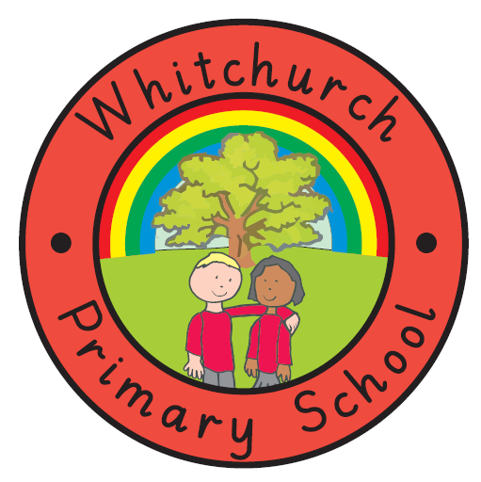
WHITCHURCH PRIMARY SCHOOL

Achieving Our Best Together

ANTI-BULLYING POLICY

RATIONALE
At Whitchurch Primary School our philosophy as stated in our Behaviour Policy and our Code of Conduct should minimise occasions of bullying. However, if bullying occurs, it will be dealt with and be seen to be dealt with because:

- Bullying makes pupils unhappy.

- Pupils who are being bullied are unlikely to concentrate fully on their school work

- Some pupils avoid being bullied by not going to school.

- Pupils who observe unchallenged bullying behaviour are likely to copy this anti-social behaviour.

Schools, which do take action against bullying, build a reputation as effective and caring schools.

AIMS
We aim to:

- Develop a culture where bullying of any form is unacceptable.

- To recognise and deal with bullying at the earliest possible stage.

- To fully support both victims and perpetrators.

- To encourage victims and witnesses to report all incidents.

GUIDELINES
What is bullying?

There are many definitions of bullying, but most have three things in common:

- It is deliberate hurtful behaviour.

- It is repeated often over a period of time.

- It is difficult for those being bullied to defend themselves.

Bullying can take many forms but the three main types are:
Physical - hitting, kicking, taking belongings.
Verbal - name calling, insulting, racist/sexist/ homophobic or that which goes against protected characteristics remarks.
Indirect - spreading nasty stories about someone, excluding someone from social groups.
Cyber Bullying
A number of positive steps can be taken both within the teaching of PHSE and the general school curriculum:

- Reward positive, non-aggressive behaviour

- Using opportunities provided by structured play, stories and role play to learn about the effect of behaviour on one another.

- Raising the self-esteem of all through activities that are designed to improve social skills.

- Circle time discussions.

- Being aware that playgrounds, corridors and hidden corners are areas in which bullying may occur.

- Providing a confidential means of reporting incidences of bullying to senior staff, thereby empowering pupils who feel too intimidated or too embarrassed to voice their complaints/concerns publicly.

PROCEDURES IF BULLYING OCCURS
Pupils will know that the school cares about bullying and will be encouraged to speak to a member of staff if they feel they are being bullied.

Pupils will know they have confidential access to senior members of staff from posters around our school.

Pupils will know that they can report bullying anonymously using the ‘friendship and fall-out box’. What the children have to say will be taken seriously and the Headteacher, Deputy Headteacher and the Senior Management Team will deal with each case appropriately. All employees in contact with affected children will be informed of any action.

Victims will be given appropriate support and bullies will be shown that there is an attitude of ‘zero tolerance’ towards their behaviour, and that they can satisfy their needs through working with others rather than in confrontational or competitive ways.

In practise an SMT member will first speak to the victim, and then to the child accused of bullying, using a restorative conversation approach. If necessary parents will also be contacted to discuss the issue. A method of rectifying any discovered issues will be created, agreed by all and put into practise. This will be monitored until all parties are happy bullying is no longer an issue.

Incidents will be centrally in the school. Parents of all children concerned will be informed.

CONCLUSION
Children will feel happy and safe at Whitchurch Primary School knowing that there is zero tolerance towards bullying.

Action Arising From The Policy

Teachers are required to support this policy by:

- Displaying our school rules: Be Ready, Be Kind, Be Safe.

- Discuss the above rules at least once per term with their class.

- Supervise their own class during ‘wet breaks’, and for a short time the class of a neighbouring teacher.

- Year 6 teachers to suggest the names of pupils who they feel deserve to be awarded the WWPW Cup.

- Praise pupils in ‘Praise’ Assembly.

- Award Class points

- Use the “sun and cloud” system in class.

- Keep a class log of serious and/or persistent pupil misbehaviour if requested.

- Report to the Headteacher or Deputy Headteacher any racist/sexist/ homophobic or that which goes against protected characteristics incident.

- Show ‘zero’ tolerance for any behaviour that could be characterised as racist/sexist/ homophobic or that which goes against protected characteristics.

- Promote anti-racist/sexist/ homophobic or that which goes against protected characteristics behaviour.

- Keep the Headteacher (and if appropriate other staff) informed about persistent and/or serious pupil misbehaviour.

- Discuss communications with parents/carers with the Headteacher where appropriate.

Policy Amended: December 2023
Next Review Date: December 2024.

