How to use Microsoft Teams

- Go to www.office.com or Google ‘Office 365’.

- You should see this screen:

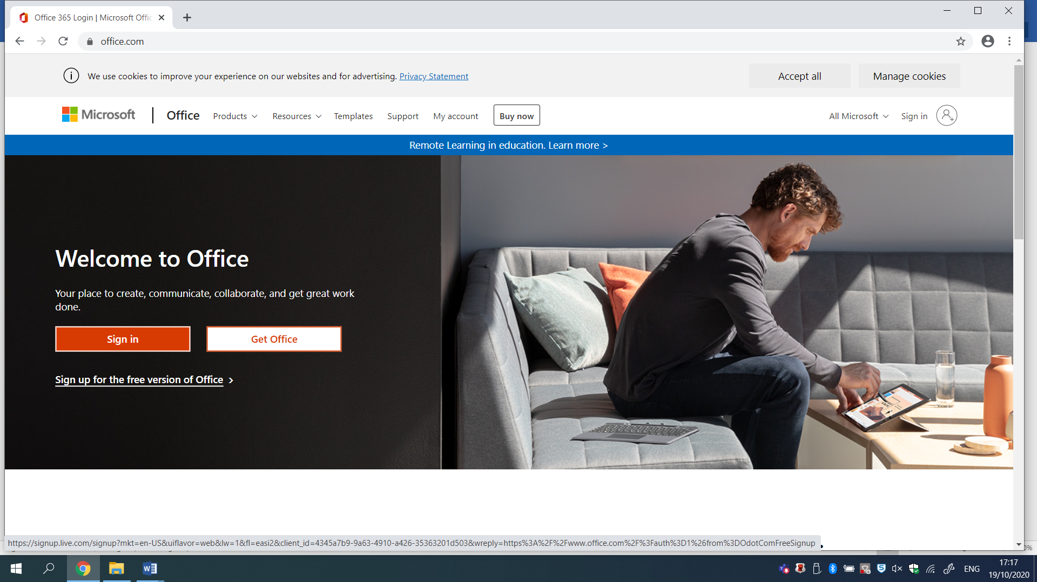
Sign in by clicking here, and entering your email and password.
This must be the email provided to you by the school, not your own personal one.

- You should see this screen:

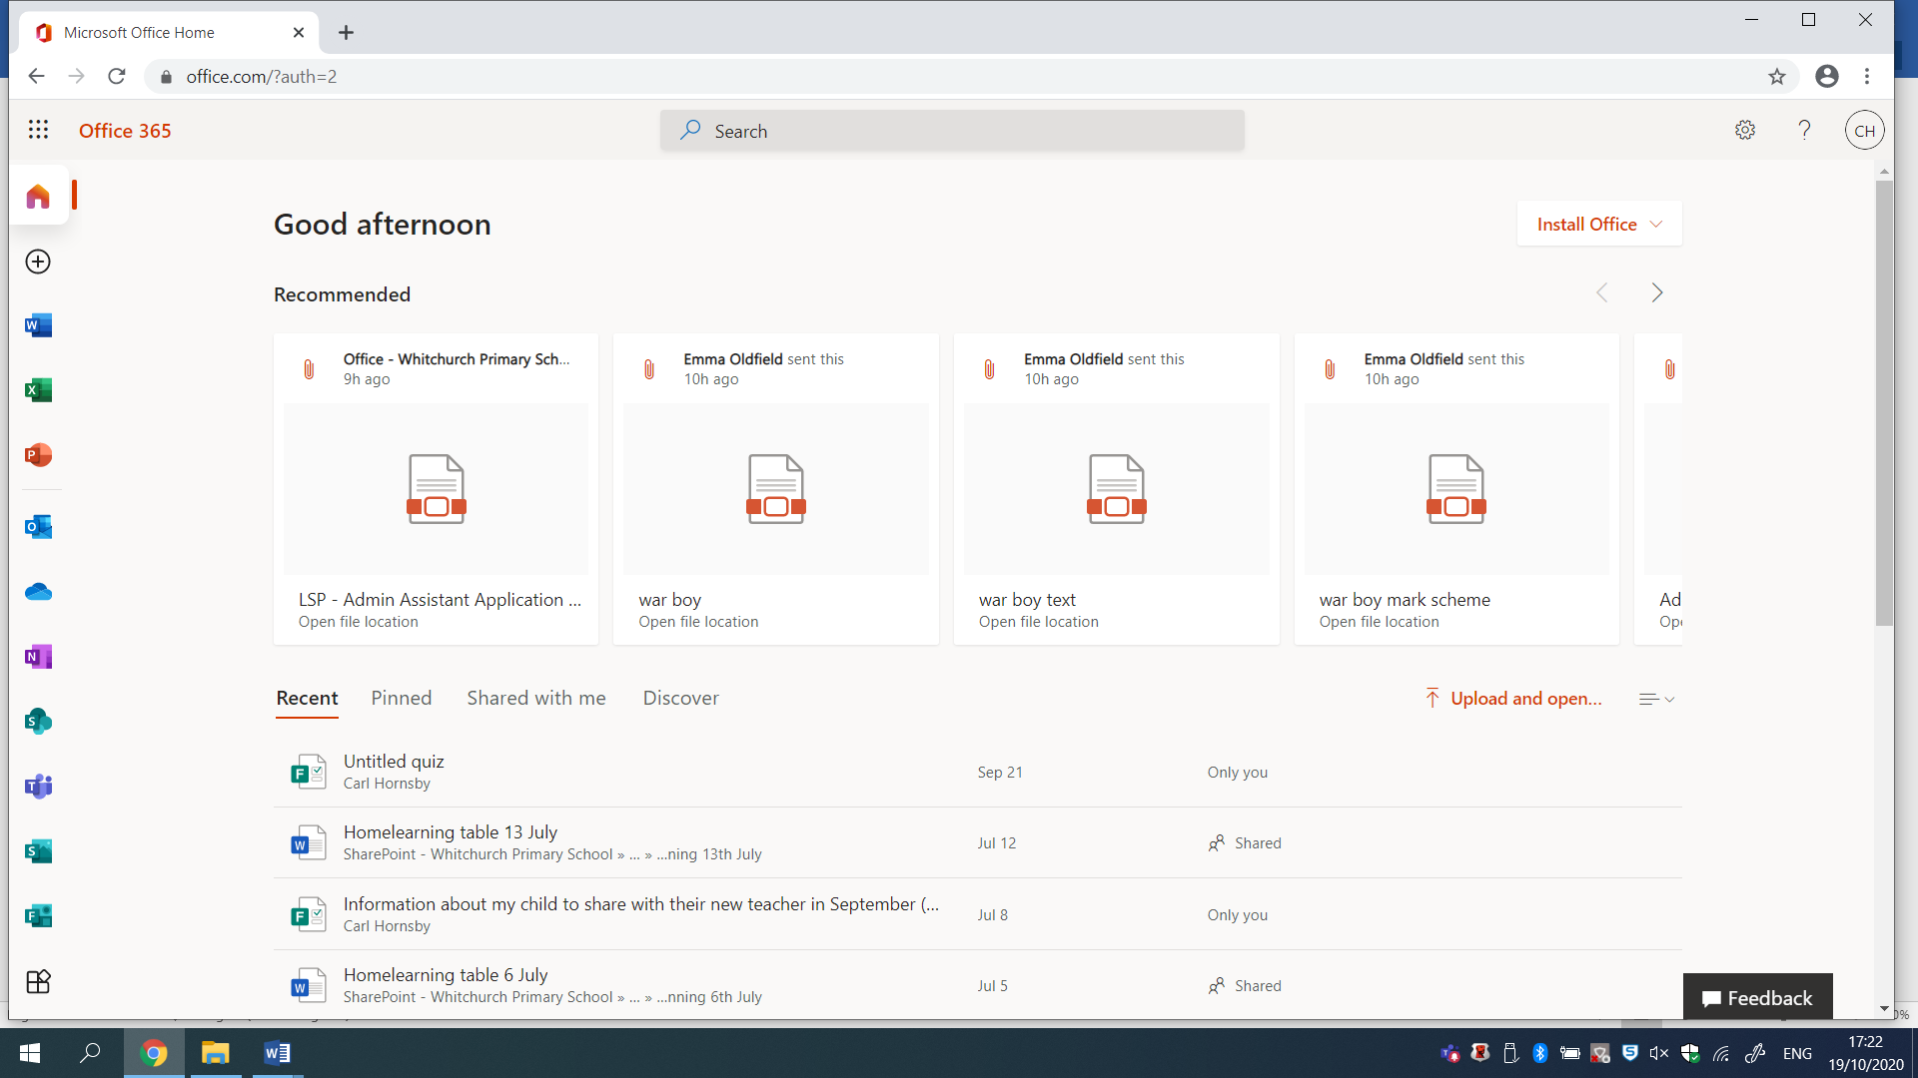
Click on the blue icon that looks like two people and a ‘T’. It says ‘Teams’ when you hover by it.

- You should see this screen (or one similar for your child’s year group):

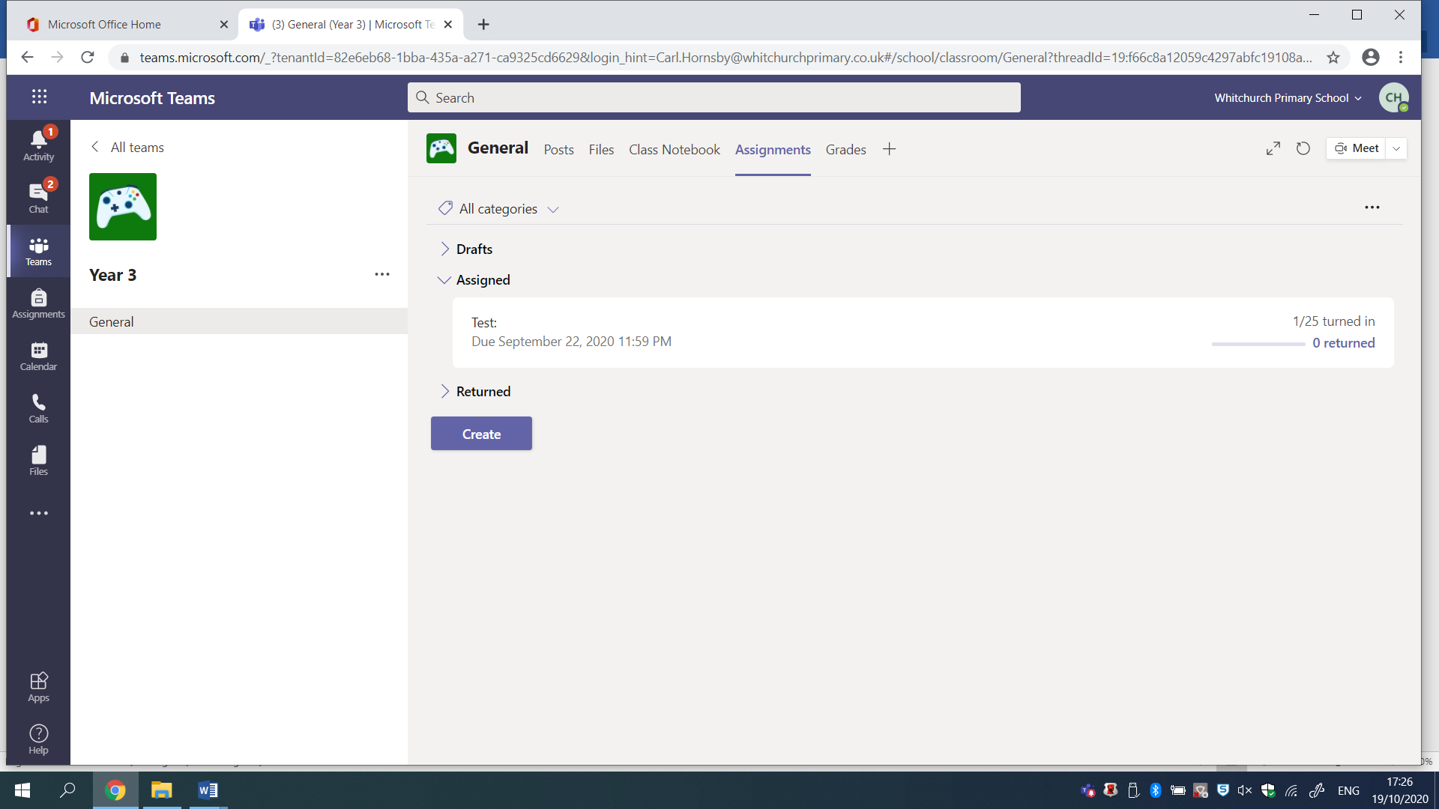
Click on Files to see files of work you can download.
Click on Assignments to find homework set by the teacher.
When a ‘video lesson’ takes place, click on the screen that will automatically appear: 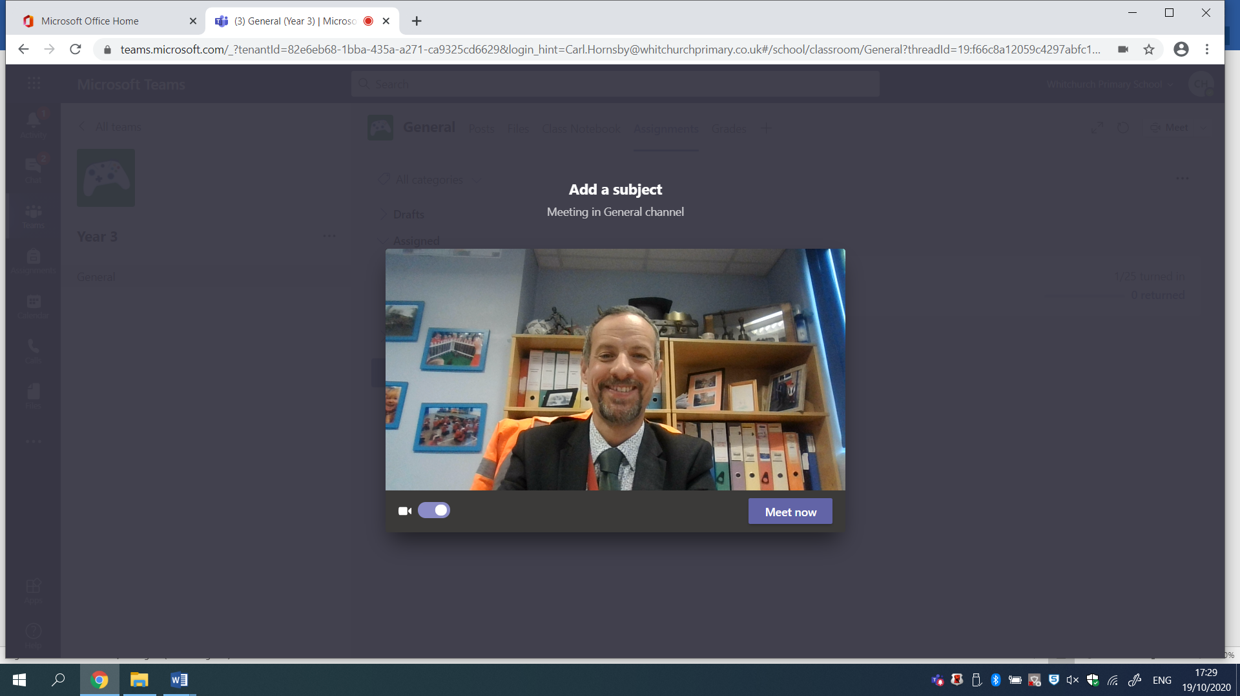

Please note at present we are only using assignments to set written homework. In the event of a second lockdown, or local lockdown, we will move to video lessons. You will be emailed and sent a text if and when these take place.

