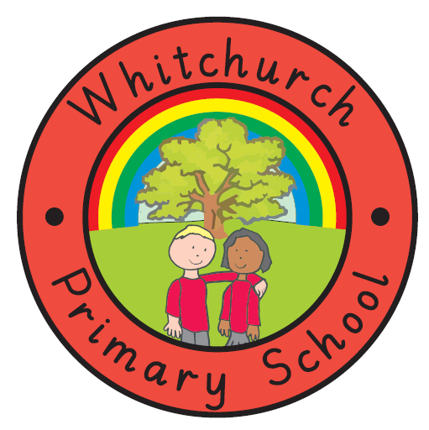
Whitchurch Primary School
Achieving Our Best Together.

Packed Lunch contents.

In order to help us maintain our ‘Healthy School’ Award, please could we draw parents attention to the following information:

Packed lunches are, of course, an important part of your child’s school day. Please help us to make sure all children receive a healthy, nutritious and balanced diet by following the guidelines below when creating your child’s packed lunch:

Items to include:
Starchy Foods  (These should make up 1/3 of the lunch box) | Sandwiches, Bagels, Pitta Bread, Wraps, Baguettes, Breadsticks, Crackers, Rice, Pasta, Noodles.
Protein Foods | Meat (Ham, chicken etc) Fish, Beans (mixed in a pasta salad?), Eggs.
Dairy Items | Cheese, Yoghurt, Fromage Frais, Milk.
Vegetable or Salad Item | Chopped up vegetables (Carrots, Peppers) with (or without) hummus or cottage cheese.
Fruit Item | Kiwi, melon etc but not dried fruit.

So, a healthy packed lunch could include: A ham sandwich and breadstick with hummus, chopped carrots, a yoghurt and banana.
OR: A chicken wrap with beans and pasta salad, with milk, chopped peppers and an apple.

Please help us further by only providing crisps or cake/biscuit based products on a Friday (as school dinners have chips). Please avoid chocolate based products and remember we are a nut free school.

By following these guidelines we can ensure that Whitchurch Primary School is a place where all ‘achieve their best together’ concerning not only education and enjoyment but health matters also.

Thank you.

