Whitchurch Primary School
‘Achieving Our Best Together.’

PE and Sport Premium Spending for 2019-2020

Each year we are given funding to improve PE and School sport.

The impact of this funding is measured by:

- achievement in weekly PE lessons;
- increased participation in competitive school sport;
- personal health and well-being
- improved attitudes and behaviour towards learning.

This document details:

- the amount of grant received
- how it has, or will be, spent.
- what impact the school has seen on pupils’ PE and sport participation and attainment.

We were very proud to win the 2019 Jaguar Formula 1 race competition, in which we competed against schools nationwide to design and construct a model F1 car that achieved a speed of 68mph!

In 2019-2020 we received £12,661 in PE and Sport Premium Spending. The document below shows what it was spent on, and the impact of this spending.

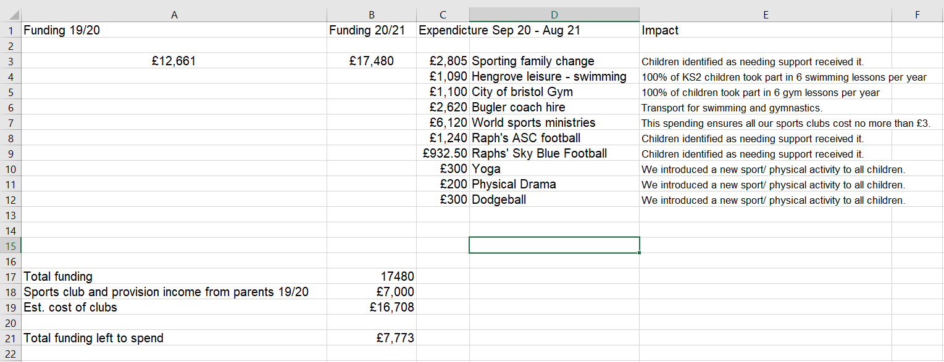

Due to Coronavirus (Covid 19) not all of these activities were able to continue into Term 5 and 6 of 2019-2020. Remaining funds were combined with new funding from 2020-2021 to fund renovations of our EYFS outdoor play/sports/PE area.
The revised budget, alongside our plans for the new area can be seen below.
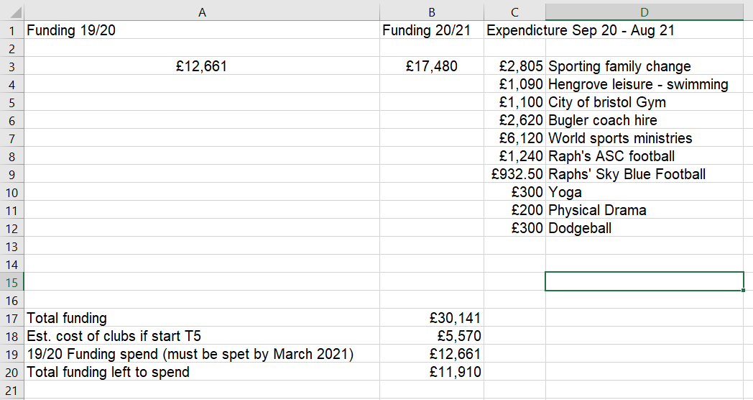
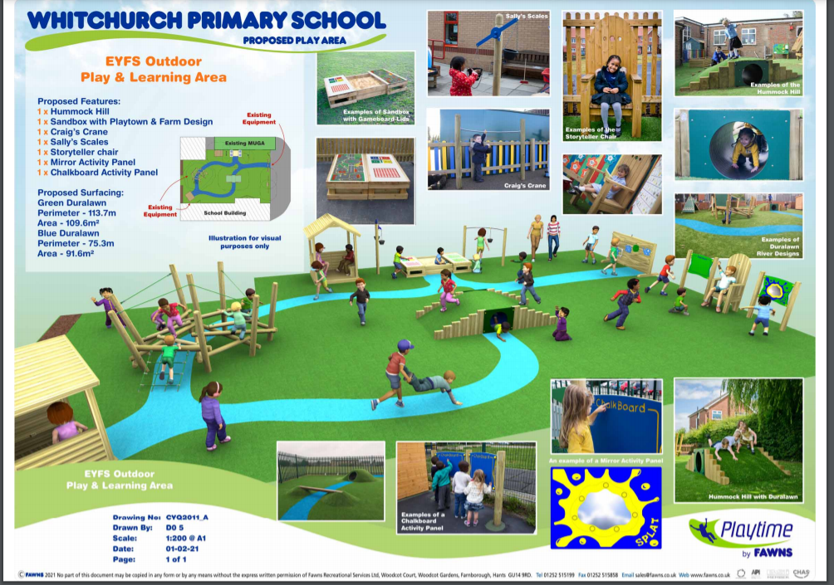

The impact of these measures are:

- 100% of children identified as needing social/emotional/ well being support through sport received it.
- 100% of KS2 children received 6 swimming lessons a year (12 in Year 3) at an Olympic pool.
- 100% of all children received 6 gymnastics lessons at a world class gymnastics centre.
- Extra curricula activities could be costed at no more than £3 per child. We also ran at least one free PE/ Sports club for each year group. (Not mentioned above as no charge or cost)
- 100% of children were introduced to 3 new sports throughout the year.

- We have been able to create an inspiring and exciting new play/ sports/ PE area for the youngest children in our school.

Whitchurch Primary School
‘Achieving Our Best Together.’

Swimming Impact 2019-2020.

The below information details the percentage of pupils within their year 6 cohort that can do each of the following:

 | 2018 | 2019 | 2020
Swim competently, confidently, and proficiently over at least 25 metres. | 100% | 97% | 72%
Use a range of strokes effectively. | NA | 97% | 79%
Perform safe self-rescue in different water-based situation | NA | 97% | 38%

Whitchurch Primary School
‘Achieving Our Best Together.’

PE and Sport Premium Projections for 2020-2021

The below chart details how we intend to sustain our improvements into this academic year:

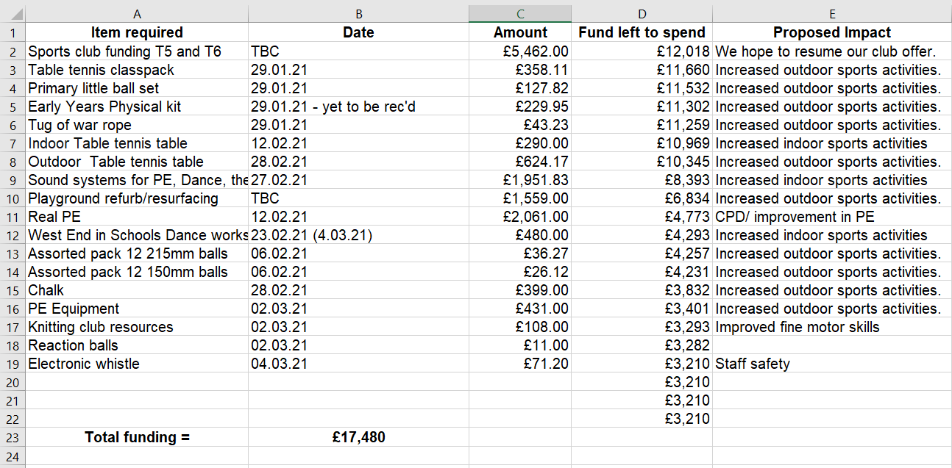

Next update: July 2021

