Whitchurch Primary School
‘Achieving Our Best Together.’

PE and Sport Premium Spending for 2020-2021

Each year we are given funding to improve PE and School sport.

The impact of this funding is measured by:

- achievement in weekly PE lessons;
- increased participation in competitive school sport;
- personal health and well-being
- improved attitudes and behaviour towards learning.

This document details:

- the amount of grant received
- how it has, or will be, spent.
- what impact the school has seen on pupils’ PE and sport participation and attainment.

We were very proud to win the 2019 Jaguar Formula 1 race competition, in which we competed against schools nationwide to design and construct a model F1 car that achieved a speed of 68mph!

In 2020-2021 we received £17,480 in PE and Sport Premium Spending. The document below shows what it was spent on, and the impact of this spending.

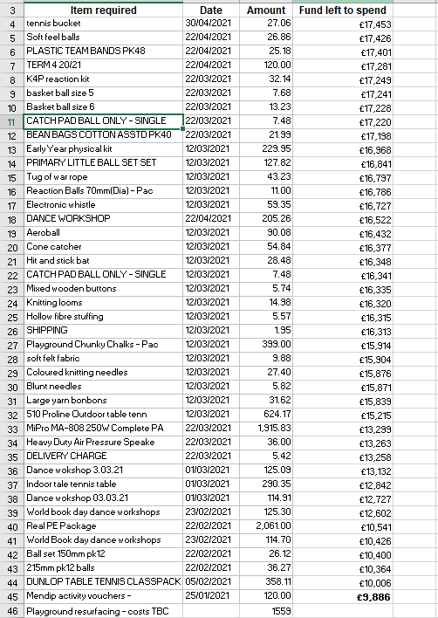

Due to Coronavirus (Covid 19) we were not able to run our usual offer of 2 clubs a day (one free of charge) or our visits to a state-of-the-art swimming pool (each KS2 child swimming for at least 6 sessions a year) or to the Olympic gymnasium (all children visit for 6 sessions a year).

To compromise, we purchased dance sessions and workshops for all children that took place over Zoom, and table tennis tables for around the school to encourage a new sport.

We also spent on new equipment to enable our new trust recommended PE Scheme of Work, REAL PE.

Other initiatives included the purchase of chalk to encourage fine motor skills at playtimes, and Dry Ski Slope vouchers given to certain children to encourage an active life style.

Remaining funds were combined with funding from 2019-2020 to fund renovations of our EYFS outdoor play/sports/PE area.

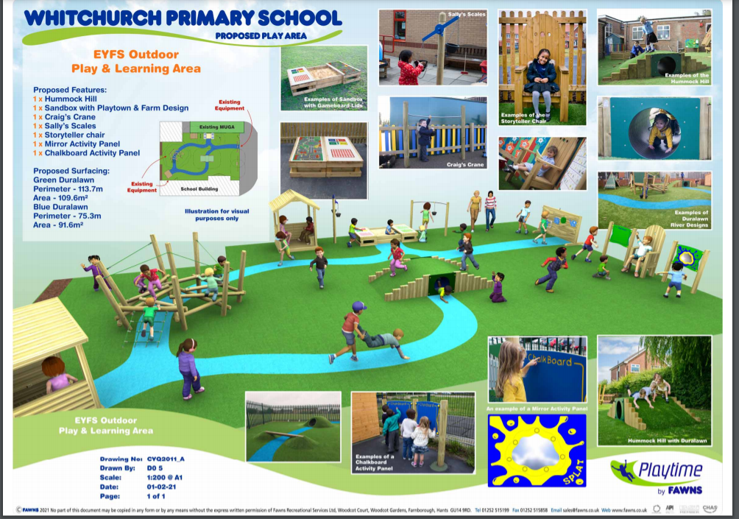

The impact of these measures are:

- 100% of children took part in at least one dance workshop over Zoom.
- 100% of children will benefit from our new PE scheme of Work and it’s accompanying resources.
- Teachers have been trained in using the new PE SoW.
- 100% of children have access to chalks to develop fine motor skills.
- 100% of children have access to our table tennis tables, thus accessing a new sport.
- Designated children received dry ski slope vouchers.

- We have been able to create an inspiring and exciting new play/ sports/ PE area for the youngest children in our school.

Whitchurch Primary School
‘Achieving Our Best Together.’

Swimming Impact 2019-2020
(Swimming impact not available for 2020 due to covid)

The below information details the percentage of pupils within their year 6 cohort that can do each of the following:

 | 2018 | 2019 | 2020
Swim competently, confidently, and proficiently over at least 25 metres. | 100% | 97% | 72%
Use a range of strokes effectively. | NA | 97% | 79%
Perform safe self-rescue in different water-based situation | NA | 97% | 38%

Whitchurch Primary School
‘Achieving Our Best Together.’

PE and Sport Premium Projections for 2021-2022

The below chart details how we intend to sustain our improvements into this academic year:

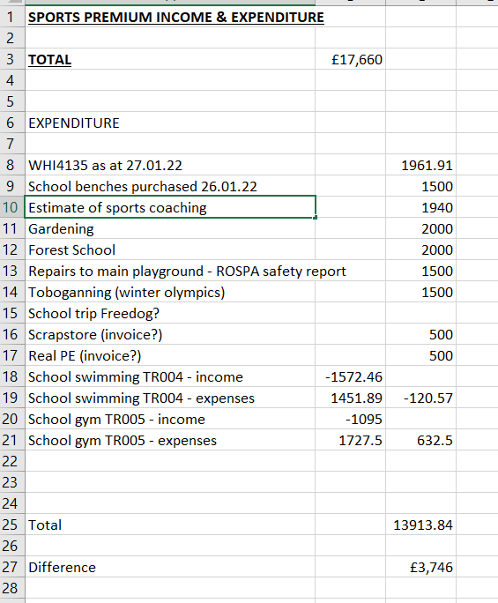
As well as reviving our aforementioned swimming and gymnasium offer to children, we plan to introduce children to two new sports (toboganing at a dry ski slope, in conjunction with the 2022 winter Olympics, and trampoline, at a local centre).
Alongside this we plan to make full use of our Forest School area, obtained in 2019 but underused due to covid. Initial ideas include a spend on forest school equipment o encourage outdoor activities, as well as the commissioning of a forest school expert to work with children and train staff!

Next update: July 2022

