**Whitchurch Primary School**

*Achieving Our Best Together*

**SATS results.**

For 2023 validated SATs results, please follow the link below:

<https://www.compare-school-performance.service.gov.uk/school/147800/whitchurch-primary-school>

We were delighted with the results our 2023 children achieved, overcoming many of the challenges faced with resilience, determination and a growth mindset. Well done class of 23!

Our 2024 unvalidated results show us above national in the following areas:

* KS2 combined SATS results.
* KS1 combined SATS results.
* Year 1 phonics results.
* Reception ‘Good level of development’

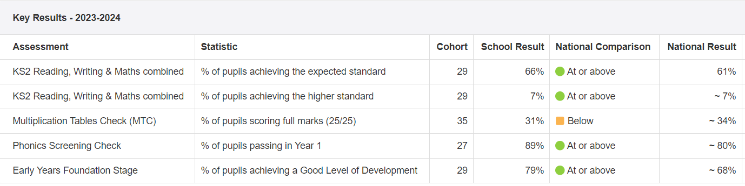

We were not above national, but broadly in-line, in the Year 4 multiplication tables check. Maths is rightfully a focus as we move in to this academic year.

Overall, we congratulate our Year 6 class of 2024 for performing above national in the combined KS2 SATs, as did the cohorts of 2022 and 2019 (no tests in 20 or 21 due to covid)

