Whitchurch Primary School
‘Achieving Our Best Together.’

Coronavirus (Covid-19) Catch Up Spending 2020-2021

How do we intend to spend our grant?

The chart below shows how we intend to spend our grant. Predominantly we will use funding to part pay for an academic mentor, who will support classes and groups recognised through the methods below. We will also fund a Teaching Assistant to carry out work recognised by individual teachers.
We will spend additional amounts on resources and equipment to improve education across the school and aid children in recovering educationally from the pandemic.

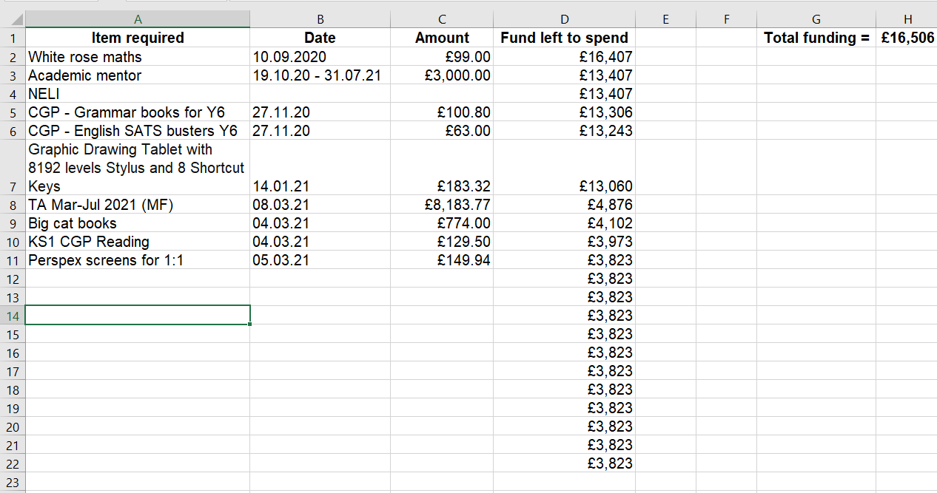

How will the effect of this expenditure on the educational attainment of those pupils at the school be assessed?

We will assess the effect of our Catch-Up Spending on children’s educational attainment by:

- Measuring through Teacher Assessment.
- Measuring through our ‘cold’ and ‘hot’ tasks; where children complete a piece of work before a unit of learning, and then again at the end. Progress can be seen through these documents.
- Analysing the results of assessments. We will use a baseline of assessments completed in January, these being KS1 Phonics test, Year 2 2017 SATS, 3,4 and 5 NFER Autumn tests and Year 6 2017 SATS.
- These results will be measured against assessments in June, these being KS1 Phonics test, Year 2 2019 SATS, 3,4 and 5 NFER Summer tests and Year 6 2019 SATS.

April 2021.

