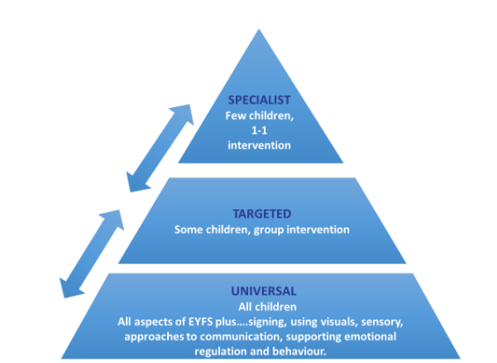

Universal provision is based on inclusive approaches to teaching and learning which benefit all children but are essential for those with SEND. Reasonable adjustments for individual needs are made to ensure schools and settings are, for example, dyslexia-friendly, communication-supportive and adaptive for any sensory and physical needs that pupils may have. At Whitchurch, we have categorised those into three key areas.

|  |
| --- |
| **High Quality Teaching and learning** |
| * A broad and balanced curriculum set within inclusive environments with policies in place for identifying and supporting children across the school * Teachers and support staff delivering learning use explicit instruction with clear explanations, modelling before pupils move to independent learning. * Scaffolds are used within learning until pupils are able to learn without them. E.g., sentence stems, writing frames, word banks etc. * Flexible groups within the class are created in response to assessment for learning so that the teacher can pitch learning for each pupil. * Technology is used to support pupils, where needed to learn well e.g., use of alternative recording device / iPad apps for learners. * Carefully planned support - Where appropriate the teacher / learning support assistants use supportive strategies for pupils. * Visuals to support learning e.g., checklists, now and next tasks, chunking/ blocking of information and the use of InPrint to aid visual learners. * Discussion through talk partners used effectively * A good CPD and training offer for our staff * Phonics interventions from Unlocking Letters and Sounds, Catch Up Numeracy, Drawing and Talking therapy and Social Communication interventions. |

|  |
| --- |
| **Physical Adaptations** |
| * Clutter free learning environments * Calm classrooms with purposeful learning only on walls * Careful seating plans taking into account individual needs * Clearly organised learning environment * Use of visual timetables and social stories * Forward facing seating where the main focus is the teacher and the boards * Phonic/ sound or word mats accessible and visible * Headphones / individually visually separate work space available for those that need a quiet pace * Wobble cushions * Pencil grips, writing slopes * Fidget toys * Access to weighted blanket/ other weighted resource for those that need them * Now and Next boards |
| **Pastoral** |
| * Senior Leadership team available most mornings on the school gates * Morning check ins from key members of staff * Soft starts and regulating activities if required for pupils who struggle with coming in to school * Access to Lunch Bunch (if hall is too noisy) * Teachers / support staff use PACE and trauma informed strategies for supporting pupils * Clear whole school behaviour policy * Consistent use of rewards and sanctions * A range of opportunities for social and emotional development E.g. Talkabout * Pastoral support from Senior Mental Health lead for children and families * Access to interventions from BANES Mental Health Support Team * Enhanced transition opportunities * Good transition processes between year groups and when joining / leaving the school |