Whitchurch Primary School.
Achieving Our Best Together.
2018-2019 Results.
‘Another great year for Whitchurch Primary School!’

Children finish primary school at the end of Year 6. They complete ‘SATS’ tests to grade whether they are working ‘below the required standard’ at the ‘required standard’ or ‘working at greater depth.’ This is then compared to the national average.

AT THE REQUIRED STANDARD | Reading | Writing | Maths | SPAG  (Spelling, punctuation and grammar.) | COMBINED
Whitchurch Primary | 80% | 80% | 90% | 83% | 77%
National | 73% | 79% | 79% | 78% | 65%
 | We are above National Ave. | We are above National Ave. | We are above National Ave. | We are above National Ave. | We are above National Ave.

WORKING AT GREATER DEPTH | Reading | Writing | Maths | SPAG | COMBINED
Whitchurch Primary | 14% | 3% | 30% | 33% | 3%
National | 27% | 20% | 27% | 35% | 11%
 | We are below National. | We are below National. | We are above National Ave. | We are below National. | We are below National
We have overhauled our reading system having visited schools locally and nationally. By combining our findings with research we have implemented a new reading system and anticipate being above national in all areas in 2020.

In addition, this table shows the progress measures of children from KS1 to KS2, where 0 is expected progress.
Reading | Writing | Maths
-1.1 | -2.3 | 0

‘How is the rest of the school doing?’
Children are also compared to government national results at the end of EYFS (their first year in school), Year 1 and Year 2. We track children in school every 6 weeks, and provide this progress information to parents. We are proud to be the only school in the region that does this.

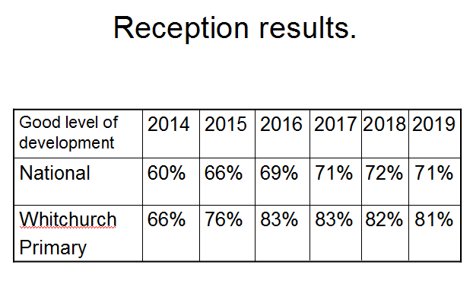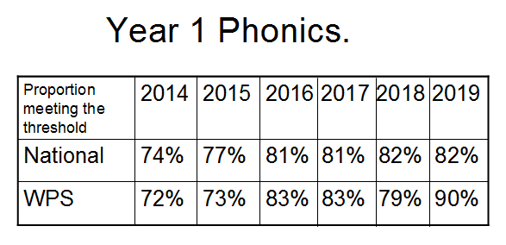
In Reception class the government aims for children to have a ‘good level of development’. As you can see we have outperformed national for 6 years running. In Year 1 the government aims for children to learn phonics for reading and writing. When we did not perform above national in 2018 quick steps were taken to see us rise well above national in 2019!

