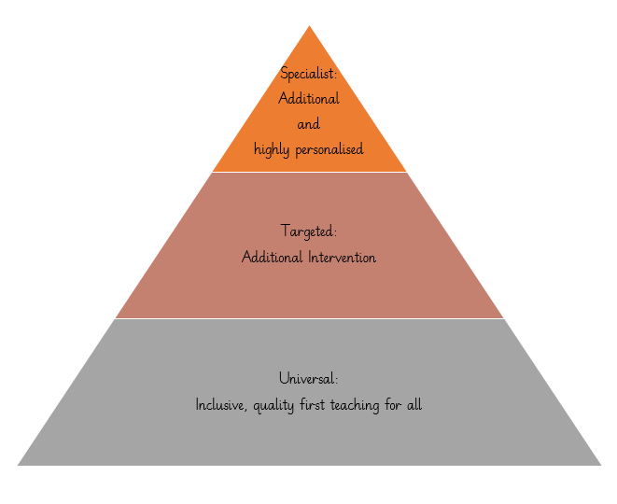**Universal Provision**

Universal provision is based on inclusive approaches to teaching and learning which benefit all children but are essential for those with SEND. Reasonable adjustments for individual needs are made to ensure schools and settings are, for example, dyslexia-friendly, communication-supportive and adaptive for any sensory and physical needs that pupils may have. At Whitchurch, we have categorised those into three key areas.

**High Quality Teaching and Learning**

**Physical Adaptations**

**Pastoral**