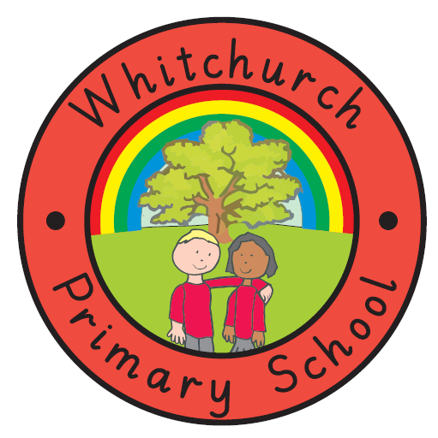
WHITCHURCH PRIMARY SCHOOL

Achieving Our Best Together

ANTI-BULLYING POLICY
‘The repetitive, intentional hurting of one person or group by another person or group, where the relationship involves an imbalance of power. Bullying can be physical, verbal or psychological. It can happen face-to-face or online’.
ANTI-BULLYING ALLIANCE Definition of bullying
In the above definition repetitive is the key word. Bullying is where one child, or a group of children, are repetitively unkind to another person, or group of children. The unkind behaviour takes place again and again, over a length of time. It is the same child repeating their unkind behaviour to another child.
Bullying is not a falling out, name-calling or disagreement as a one off. If this happens, it is treated as a behaviour incident in accordance with the rest of this policy. As of April 2024, children are reminded of this through our STOP posters: Several Time On Purpose.
Bullying will not be tolerated. We recognise that bullying can take various forms and is distressing and detrimental to the welfare of the child being bullied. The school is aware of the dangers of Cyber Bullying and includes it in anti-bullying work.
In consultation with the School Council, a ‘Friendship/Fall-out’ box has been situated where children can easily access it and post a report directly to the Head Teacher or Deputy Head Teacher about any incidents of bullying they have themselves experienced or seen.
The Head Teacher and Deputy Head are responsible for ensuring that the ‘Friendship/ Fall-out’ Box is checked regularly and that swift and appropriate action is taken where bullying is found to be occurring. The Head Teacher will inform parents if their child is bullying or has been bullied.
Of course, children know they can also tell any of the adults in school, shown on our posters. STOP: ‘Start Telling Other People’ is the key message.
Bullying and its effects should be discussed in all classes each term. Pupils will be reminded about the ‘Friendship/Fall-out’ box and how it should be used.
Bullying is also discussed in our termly governor meetings, so that leaders can be held to account on how bullying is handled.

Policy Amended: July 2025
Next Review Date: July 2026

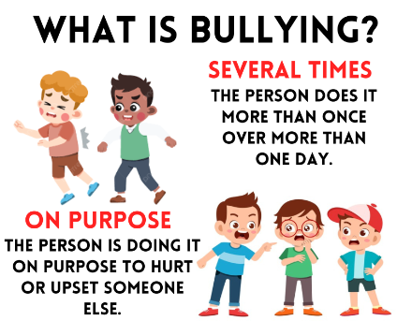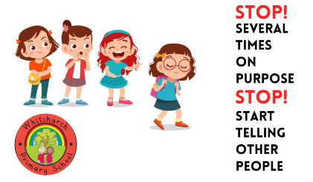

Whitchurch Primary School is an inclusive, friendly and welcoming school. We are glad our parents and carers agree, as illustrated by these ParentView survey results below:
