**Whitchurch Primary School**

**‘Achieving Our Best Together.’**

**PE and Sport Premium Spending for 2021-2022**

Each year we are given funding to improve PE and School sport.

The impact of this funding is measured by:

* achievement in weekly PE lessons;
* increased participation in competitive school sport;
* personal health and well-being
* improved attitudes and behaviour towards learning.

This document details:

* the amount of grant received
* how it has, or will be, spent.
* what impact the school has seen on pupils’ PE and sport participation and attainment.

**We are very proud to be the National Jaguar Formula One Race Challenge champions! We competed against schools nationwide to design and construct a model F1 car that achieved a speed of 68mph!**

In 2021-2022 we received £17,660 in PE and Sport Premium Spending. The document below shows what it was spent on, and the impact of this spending.

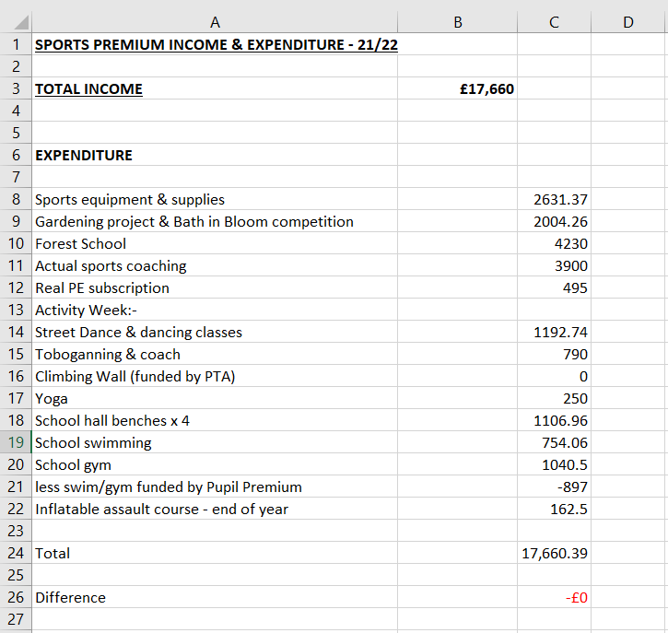

Our spend included 6 Forest School sessions for each child from a Forest School endorsed organisation. Children learned about sustainability and survival skills.

Following on from this, sports funding contributed towards our gardening club, in which children learnt about outside lifestyles and healthy living and cooking. We received a regional award in recognition of this.

Funding also went towards our ‘Week of Adventure’ encouraging children to get outside and learn new sports following covid. Children enjoyed climbing, dance, yoga and tobogganing.

We were also pleased to bring back our weekly swimming lessons, where all KS2 children receive at least 6 sessions per year, and our gym sessions, where every pupil visits a national gym 5 times a year.

Funding covered an inflatable assault course on the final day, encouraging children to stay active over the holiday.

The impact of these measures are:

* 100% of children took part in our ‘Week of Adventure’ and experienced a new sport.
* 100% of children took part in ‘Forest Schools’ and experienced outdoor skills and healthy living.
* Children took part in gardening sessions, extending their understanding of outdoor skills and healthy living.
* 100% of children will benefit from our new PE scheme of Work and its accompanying resources.
* Teachers have been trained in using the new PE SoW.
* 100% of Key Stage 2 children have experienced professional swimming tuition.
* 100% of all children have experienced professional gym tuition.
* 100% of children developed their climbing techniques on an inflatable assault course.

**Whitchurch Primary School**

**‘Achieving Our Best Together.’**

**Swimming Impact 2021-2022**

The below information details the percentage of pupils within their year 6 cohort that can do each of the following:

|  |  |  |  |  |
| --- | --- | --- | --- | --- |
|  | 2018 | 2019 | 2020 | 2022 |
| Swim competently, confidently, and proficiently over at least 25 metres. | 100% | 97% | 72% | 61% |
| Use a range of strokes effectively. | NA | 97% | 79% | 29% |
| Perform safe self-rescue in different water-based situation | NA | 97% | 38% | 74% |
|  |  |  |  |  |

Following covid (Year 6 children had missed two years of swimming) we concentrated on life saving skills and water safety.

We look forward to our results returning to those pre-covid as all children will now experience swimming each year.

Parents/carers of Year 6 children were notified of these results and encouraged to swim whenever possible.

**Whitchurch Primary School**

**‘Achieving Our Best Together.’**

**PE and Sport Premium Projections for 2022-2023**

The below chart details how we intend to sustain our improvements into this academic year:

To be added September 2022

As well as continuing our aforementioned swimming and gymnasium offer to children, we plan to introduce children to two new sports (trampolining at a new local centre, and mountain biking at a yet to be completed local centre).

Alongside this we plan to continue our Forest School sessions, with teachers having been trained by our visiting professionals. Equipment will need to be purchased for this. We plan to train one staff member as a forest school accredited member.

Further information will be added following our September 2022-2023 inset days.

Next update: July 2023